1.Create a visualization showing the products via creating hierarchies which made the maximum

profit in the last 2 years so the company could focus more on production of those products. And

create another visualization (in another sheet) showing the products which gave heavy loss to

the company in the last two years, so those could be eliminated. Lastly, create a dashboard

representing both of the sheets and don't forget to make the dashboard look presentable.1.

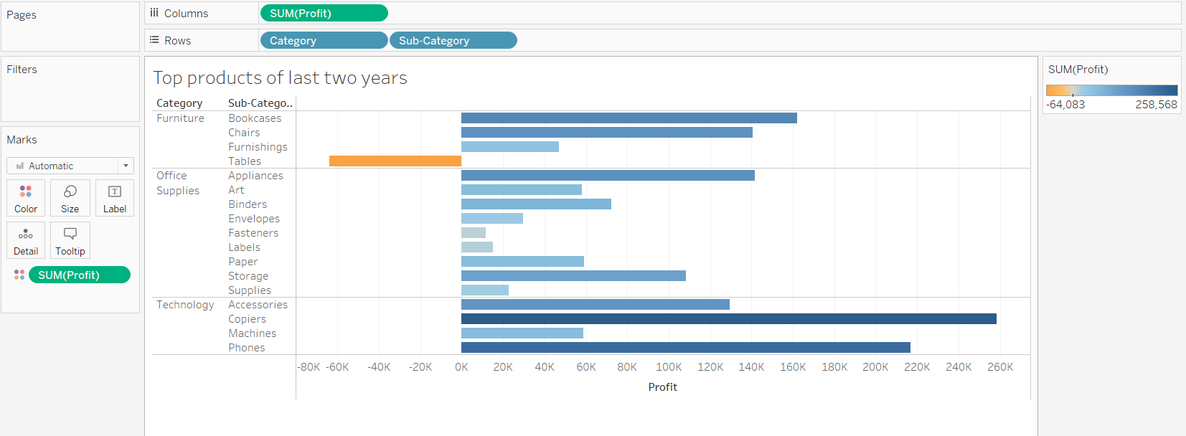

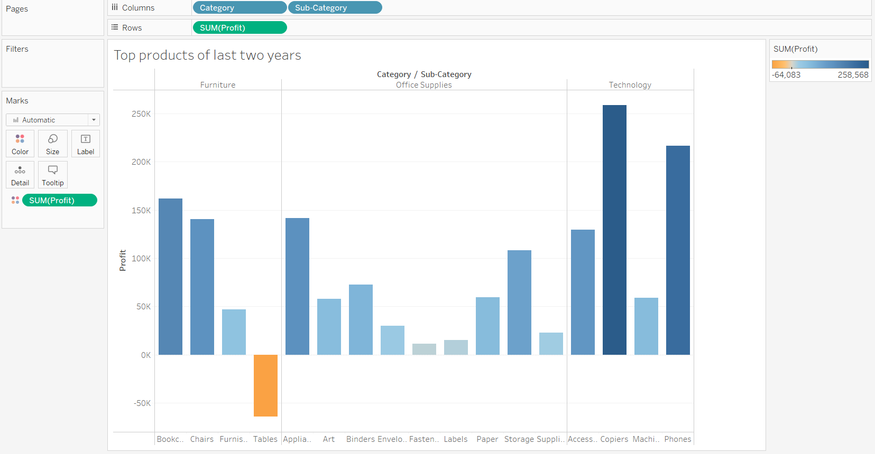

Visibally copiers and phones are top items.

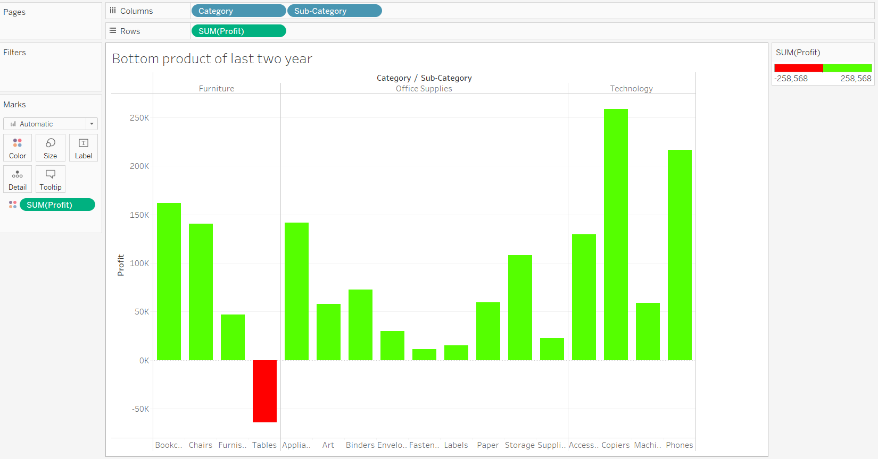

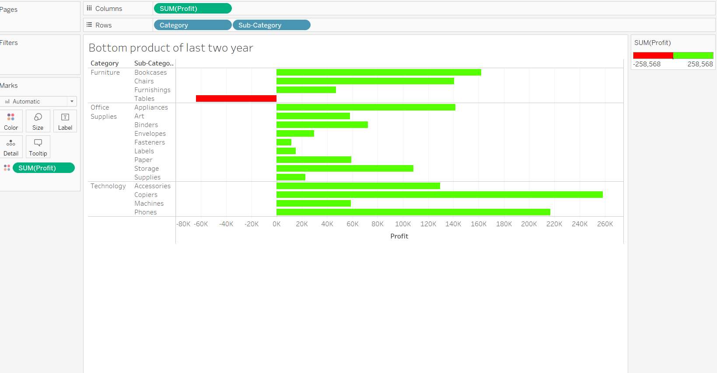

Bottom two products are Tables and fasteners.

2. Create a Gantt chart showing the time duration of Order date and ship date for the sales from

September 2013 - October 2013.

